Experiment 8:
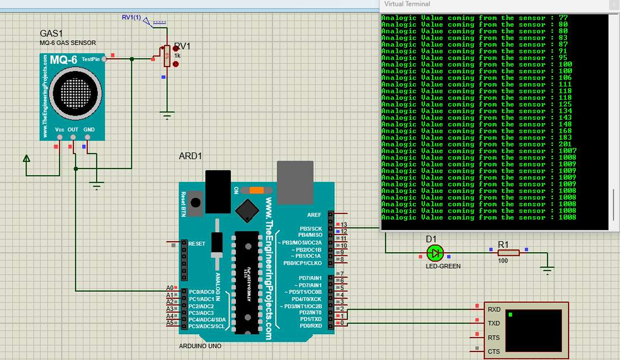
Source code:
#define GreenLed 13
#define Sensor A0
void setup(){
pinMode(13,OUTPUT);
pinMode(12,OUTPUT);
pinMode(A0,INPUT);
Serial.begin(9600);
}
void loop() {
int value = analogRead(A0);
Serial.print("Analogic Value coming from the sensor : ");
Serial.println(value);
delay(100);
if(value>600){
digitalWrite(GreenLed,HIGH);
delay(250);
}
else{
digitalWrite(GreenLed,LOW);
delay(250);
}
delay(20);
}

